Ex. No. : | 10 | Date : 25/09/2026
Register No. : | 240701629 | Name : Immanuel SA

Scheduled Tasks in Zoho Creator

Aim
To automate the repeated tasks of the RentEase application with three schedules, a daily schedule for overdue rent, a weekly schedule for the maintenance digest and a monthly schedule for rent invoices, so that these tasks run on time without anyone starting them.

Introduction

Schedules in Zoho Creator
A schedule runs a Deluge script automatically at a set date and time. It can be set to run once or to repeat every day, week, month or year. A schedule can be attached to a form, so that the script works on the records that match a criteria, or it can run without a form. Schedules are used for work that depends on time and not on a user action, such as reminders, reports, clean-up and recurring records.

Schedules in RentEase
Rent and repairs in RentEase depend on dates. Invoices fall due and become overdue, open repair requests must be followed up every week, and a new invoice is needed for every active lease each month. Doing these by hand is slow and easy to forget, so three schedules were created, one for each frequency.

Objectives of the Study
- To list the requirements that need a schedule in the rental business.
- To create a daily, a weekly and a monthly schedule in Zoho Creator.
- To use Deluge in a schedule to update records, create records and send emails.
- To verify the effect of each schedule on the application data.

Procedure
- Open the RentEase application in Edit mode and click Workflow in the top bar, then open Schedules.
- Create a new schedule for the daily overdue rent. Enter the name, select the form Rent_Invoice, set the frequency to every day and set the time.
- In the script, fetch the invoices whose Status is Unpaid and whose Due Date has passed, set their Status to Overdue, add the late fee of Rs 500 and send an email to the tenant.
- Create the weekly schedule for the maintenance digest. Set the frequency to every week, the day to Monday and the time to 8:00 AM. In the script, collect the open maintenance requests and email them to the manager.
- Create the monthly schedule for the invoice generator. Set the frequency to every month, the date to the 1st and the time to 6:00 AM. In the script, create a rent invoice for each lease whose Status is Active.
- Save the three schedules.
- Open the application in Access mode and check the invoices, the emails and the new records that the schedules produce.
1

Dept. of Computer Science and Engineering | Rajalakshmi Engineering College

- Take a screenshot of the schedules, their settings and their results.

Detailed Analysis of the Schedules
Table 1 lists the requirements of the rental business and the schedule that meets each one.

No. | Requirement | Schedule | Frequency
1 | Unpaid invoices that pass the due date must be marked Overdue, charged a late fee of Rs 500 and the tenant must be told | Overdue rent | Daily
2 | The manager must receive a list of the open repair requests at the start of every week | Maintenance digest | Weekly, Monday 8:00 AM
3 | Every active lease must get a rent invoice at the start of each month | Invoice generator | Monthly, 1st at 6:00 AM
Table 1: Schedule requirements of RentEase
Table 2 compares the settings of the three schedules.

Setting | Daily overdue rent | Weekly maintenance digest | Monthly invoice generator
Frequency | Every day | Every week | Every month
Run time | Time set in the schedule | Monday, 8:00 AM | 1st of the month, 6:00 AM
Form | Rent_Invoice | Maintenance_Request | Lease_Agreement
Records used | Unpaid invoices past the due date | Open requests | Leases with Status Active
Action | Marks Overdue, adds Rs 500 late fee | Emails the digest | Creates an invoice
Email sent to | Tenant | Manager | None
Table 2: Settings of the three schedules
Table 3 describes the logic of each schedule in steps.

Schedule | Logic
Daily overdue rent | Step 1: fetch the Rent_Invoice records with Status Unpaid and a Due Date before today. Step 2: for each record, set Status to Overdue and Late Fee to 500. Step 3: send an email to the tenant.
Weekly maintenance digest | Step 1: fetch the Maintenance_Request records that are not closed. Step 2: build a list of the requests with their status. Step 3: send the list to the manager by email.
Monthly invoice generator | Step 1: fetch the Lease_Agreement records with Status Active. Step 2: for each lease, create a Rent_Invoice record for the new billing month with the rent of the lease.
Table 3: Logic of the schedules
Because only invoices with Status Unpaid are selected by the daily schedule, an invoice that has become Overdue is not selected again, so the late fee of Rs 500 is added once. The Total Amount of the invoice is the Rent Amount plus the Late Fee, so it rises to include the fee automatically.

2 Dept. of Computer Science and Engineering | Rajalakshmi Engineering College

Output
3
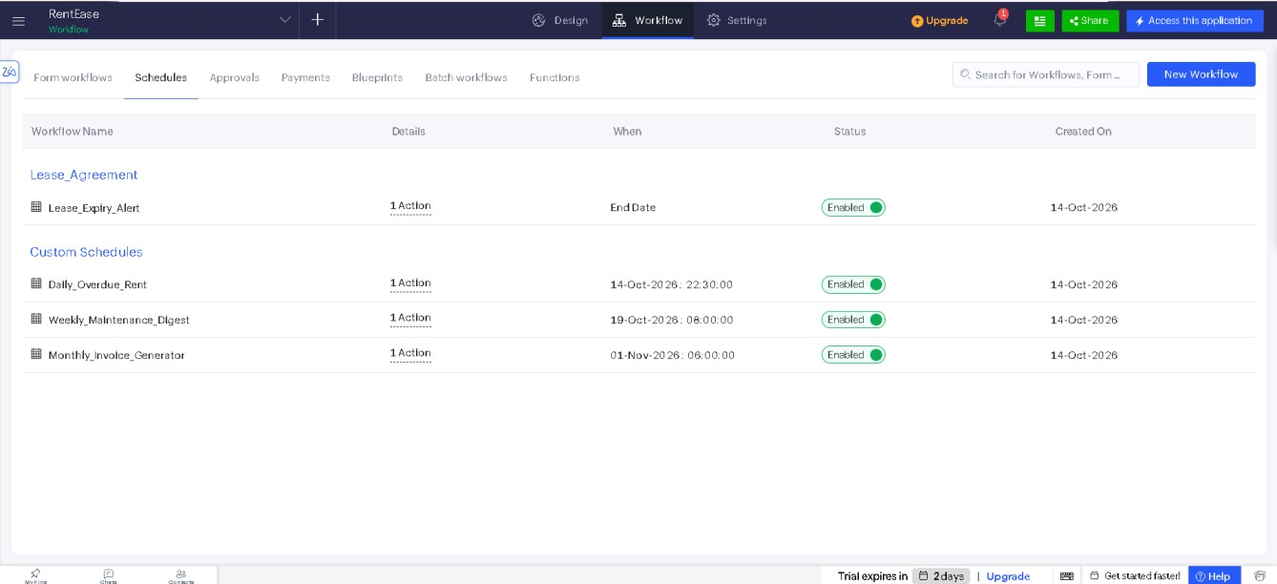
Figure 1: Schedules of RentEase
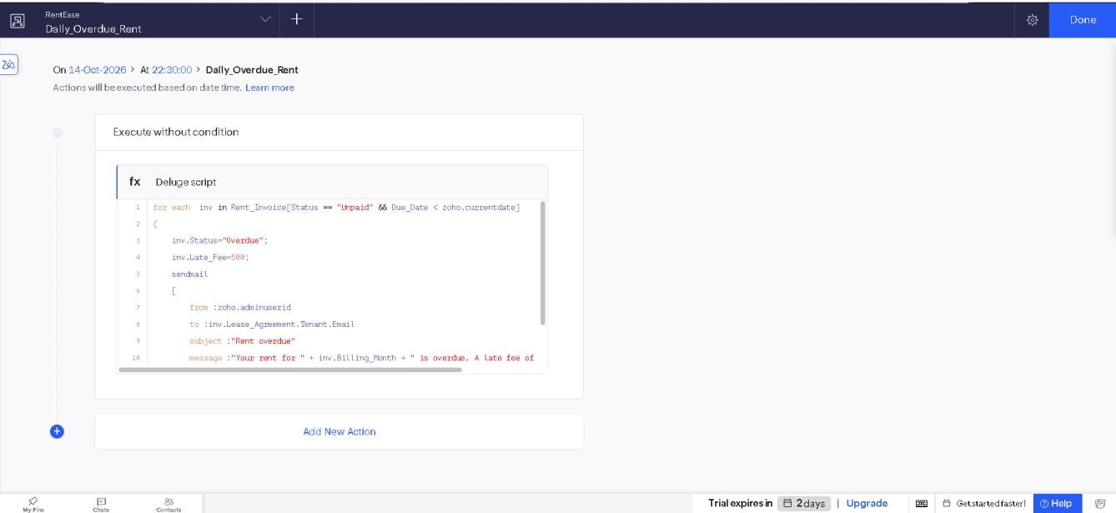
Figure 2: Daily overdue rent schedule

Dept. of Computer Science and Engineering | Rajalakshmi Engineering College

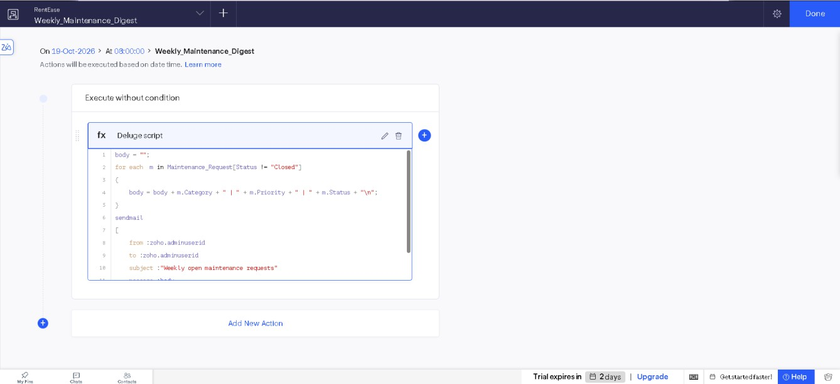
4
Figure 3: Weekly maintenance digest schedule
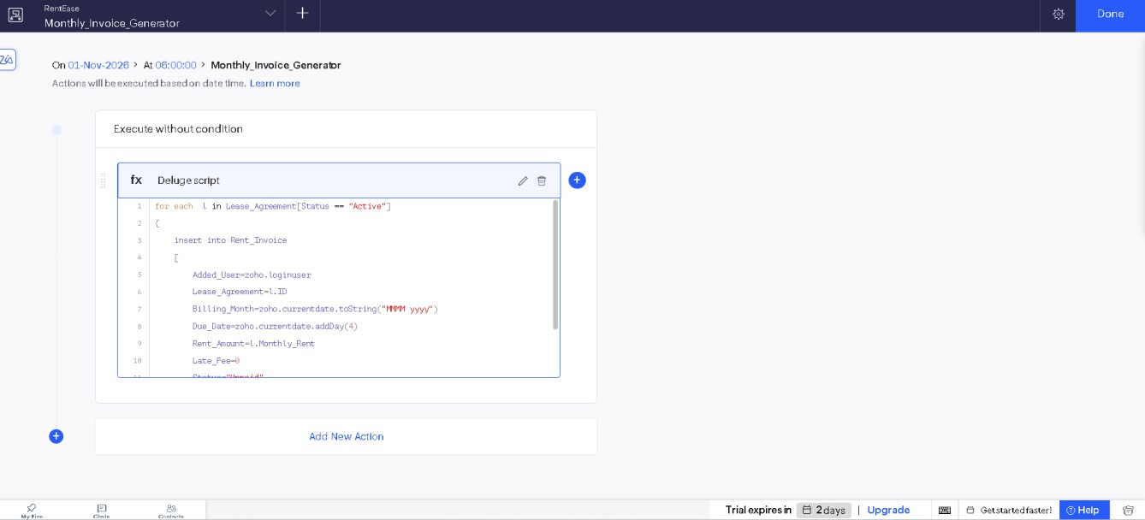
Figure 4: Monthly invoice generator schedule

Dept. of Computer Science and Engineering | Rajalakshmi Engineering College

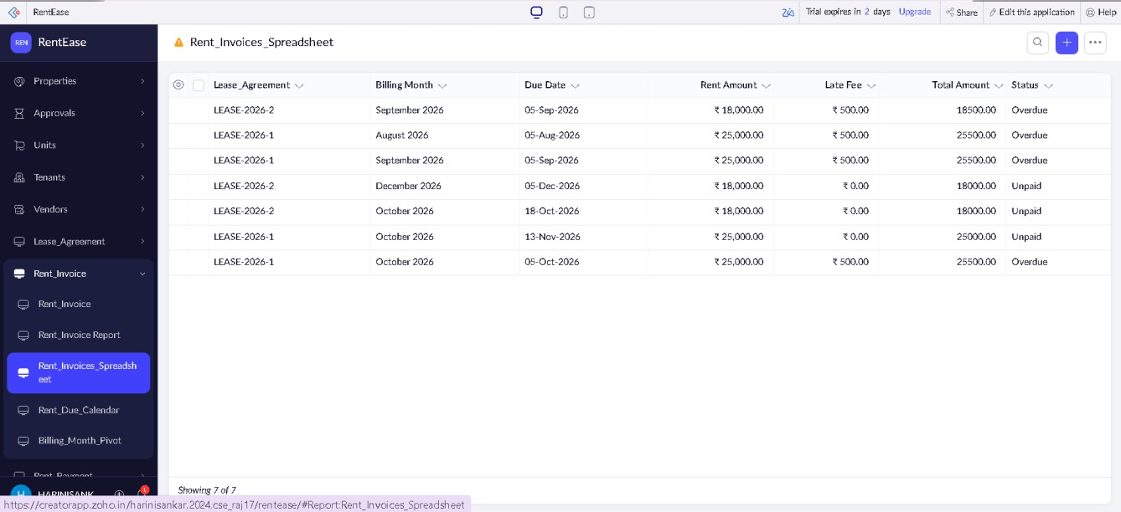
Figure 5: Overdue invoices with the late fee added by the schedule
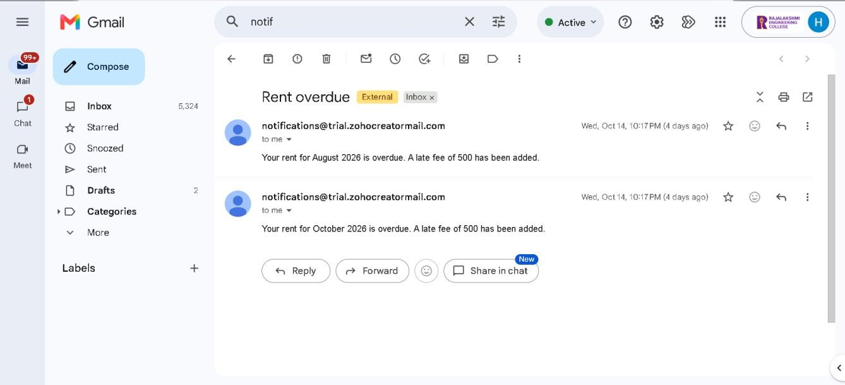
Figure 6: Email sent by a schedule

Result
The daily, weekly and monthly schedules of RentEase were created and checked. The daily schedule marks unpaid invoices as Overdue, adds the late fee of Rs 500 and notifies the tenant, the weekly schedule emails the open maintenance requests to the manager every Monday at 8:00 AM, and the monthly schedule creates an invoice for every active lease on the 1st at 6:00 AM. The repeated rental tasks now run on time without manual work.
5

Dept. of Computer Science and Engineering | Rajalakshmi Engineering College

